SSA Owned Boat Use Program 2021

This program is intended to encourage SSA member participation in the club and use of the SSA owned boats. The SSA Board purchased a Capris 18 sailboat in addition to the Holder 14 sailboats we already own. To make better use of all of our boats, the SSA Board has re-written our boat use policy.

Highlights of the policy include:
- Members can use the boats, with some restrictions, at any time they want.
- To promote responsible use of boats, a skills test and a detailed pre & post use checklist is required.
- Use of the boats is strictly limited to SSA members and their guests.

Who can use the SSA sail boats:
Each person on any SSA sail boat shall have signed a waiver and be wearing a life jacket at all times.
Each boat shall have at least one SSA member over the age of 12 on board.
An SSA member over the age of 18 shall accompany passengers under the age of 12
SSA members and their guests are the only authorized users
The boats cannot be rented or otherwise used by the general public.

In addition to being an SSA member, the person responsible for using each boat shall:
Have passed a Sailing Certification which includes:
Be able to swim
Has demonstrated basic sailing skills:
Rig, launch, tack, jibe and land the boat without assistance or running into things.
These skills shall be demonstrated on the boat the user intends to sail.
Can use a VHF radio
And / Or has attended one of the City of Sandpoint 8 hour Sailing classes
Complete the pre-use and post-use survey of the boat
Accept personal responsibility for any damage to the boat, damage to other boats or property, costs of retrieval, towing, or search and rescue efforts that may arise from use of the boat.
All Passengers on SSA Sailboats
Shall sign a waiver (Guardians sign for those under 18)
Shall be able to swim
Shall wear a life jacket at all times

Conditions of Use for Holders and the Capris 18
Weather (for both Holders and Capri 18)
Wind - Maximum sustained winds of 15 MPH. No gusts of 18 or more within the last 60 minutes. Wind measured per “Windbag Weather” link on the SSA Website.
No sailing with visible lightning or audible thunder.
No sailing with predicted weather fronts that might exceed wind limits (per VHF Weather Channel 3).
Times of use;
SSA Boats are reserved for educational programs
Holders can be sailed from ½ hour before sunrise to ½ hour after sunrise.
Capri 18 may be reserved at: CAPRI RESERVATION WEBSITE
Reservations are required for participation in a race
Reservations are required for use for more than 4 consecutive hours
Reservations are required for overnight use
Use of the Capri for less than 4 hours similar to Holders unless the boat has been reserved.
Sailing Area;
Holders: (See map of sailing areas)
West of a line from Kootenai Point to Contest Point
Not within 300 yards of the RR Bridge
Capri 18 (see map of sailing area)
West of a line from Sunnyside boat ramp to Anderson Point
300 yards north of the RR Bridge
Safety;
Mandatory use of life vests – NO exceptions.
Shall have a either a personal VHF, a club VHF or a water proof cell phone onboard.
Shall have notified someone onshore of expected travel plans and return time.
Shall have confirmed weather requirements are met by checking forecast and local conditions
Damage;
Report any damage to the quartermaster.
Check in / check out sheets shall be completed prior to and after each use.

Questions? Contact:
SSA Commodore (Jim Doudna 208-597-1725)
Quartermaster (Fred Gloor 208-721-0813)
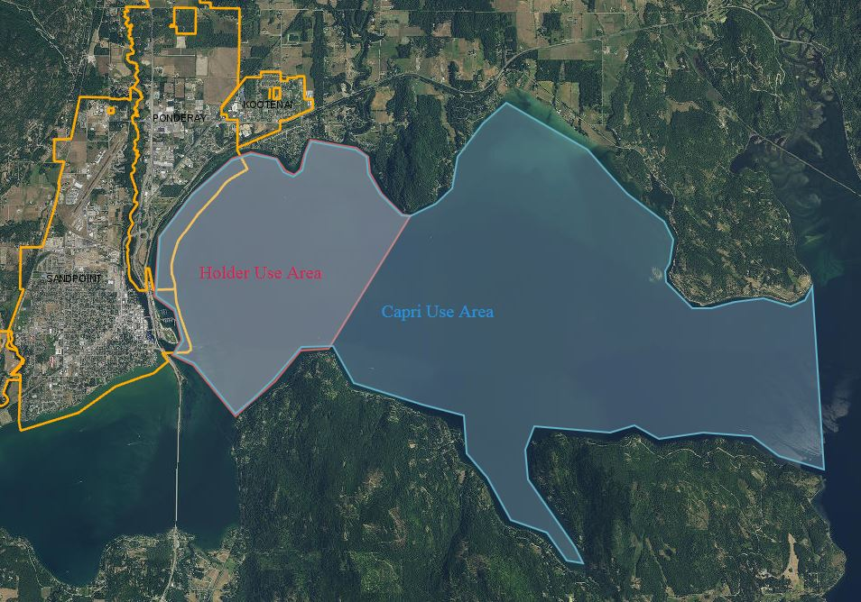
Other SSA Board Members

